**Differential Privacy Overview Page**

**Introduction to Differential Privacy**

This page introduces the concept of Differential Privacy, how it works, and why it’s crucial for protecting sensitive information in the financial sector. You’ll learn about its benefits, how it can be implemented, and real-world applications, making it a valuable tool for financial institutions aiming to balance data privacy with meaningful analysis.

**What is Differential Privacy (DP)?**

**Definition:** Differential Privacy is a privacy technique that ensures adding or removing a single data point (e.g., a person’s information) in a dataset doesn't significantly change the outcome of the analysis. This ensures the privacy of individual data within the dataset.

By adding random noise to the data, DP allows organizations to extract insights without revealing personal information, making it vital for industries like finance, where maintaining privacy is essential.

**How Differential Privacy Works**

Differential Privacy works by adding noise to data before processing. This ensures the data remains anonymous while allowing accurate analysis.

* **Step 1**: Data is collected from sources, such as customer transactions.
* **Step 2**: Random noise is added to mask individual records while keeping patterns intact.
* **Step 3**: Data is analysed, providing insights without exposing personal information.

This method protects personal data while still allowing financial institutions to make important decisions.

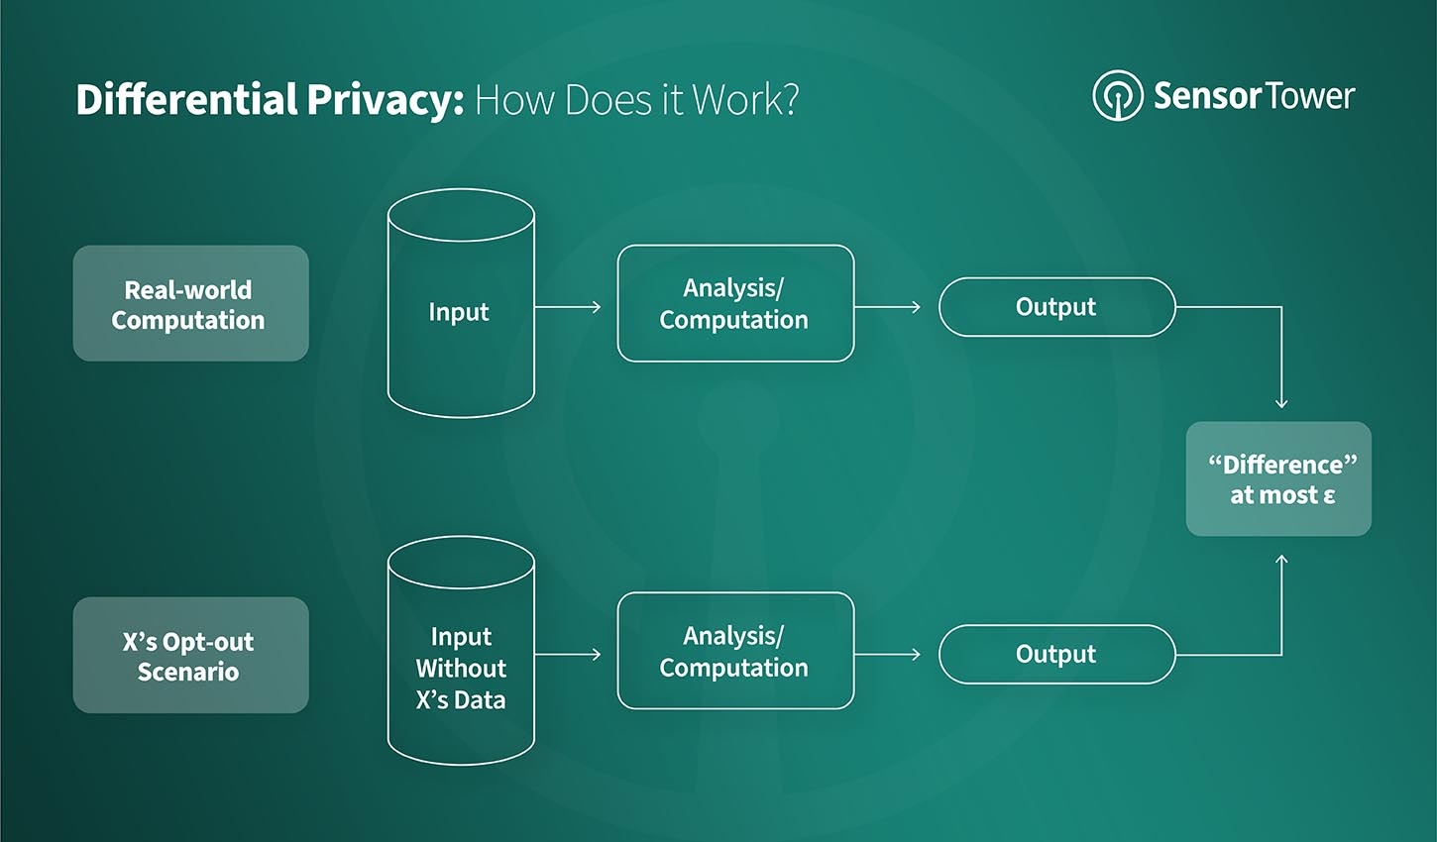

**Benefits of Differential Privacy in Financial Services**

Differential Privacy offers several key benefits, particularly in the context of financial services:

1. **Enhanced Privacy:** Protects individual customer data, even in large datasets.
2. **Regulatory Compliance:** Helps comply with privacy laws like GDPR and CCPA.
3. **Accurate Insights:** Allows for meaningful insights while maintaining privacy.
4. **Protection Against Re-identification:** Prevents the identification of individuals from aggregate data.
5. **Flexibility:** Can be used with many types of data, including transactions and customer behaviour.

**Market Trends and Adoption of Differential Privacy**

As data privacy becomes more important, more financial institutions are adopting Differential Privacy. Regulatory bodies are pushing the industry to use more privacy-preserving technologies.

* **Growing Adoption**: More companies are using DP to address privacy concerns.
* **Regulatory Push**: Financial services are increasingly required to adopt privacy-preserving measures.

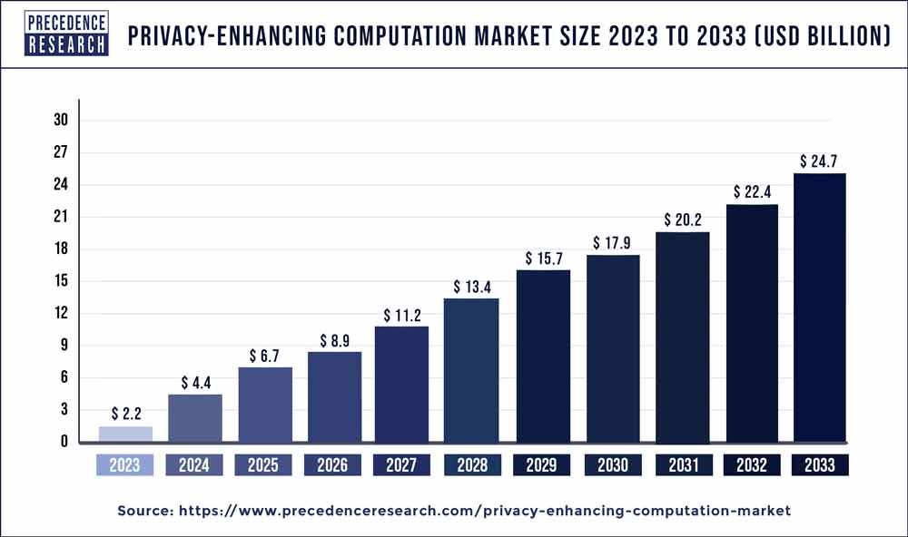

**How to Implement Differential Privacy**

Here’s how to implement DP in financial services:

* **Step 1: Define the Data**: Identify the sensitive data that needs protection.
* **Step 2: Add Noise**: Apply random noise to mask personal data while maintaining patterns.
* **Step 3: Process Data**: Analyse the masked data to gain insights.
* **Step 4: Report Results**: Share insights while ensuring privacy is maintained.

**Real-World Applications of Differential Privacy in Finance**

Differential Privacy has many practical applications in the financial sector, including:

1. **Fraud Detection**: Allows financial institutions to analyse transactions to detect fraud patterns without compromising individual data.
2. **Customer Behaviour Analysis**: Enables institutions to understand customer behaviour and preferences while maintaining privacy.
3. **Risk Management**: Helps in evaluating risks while ensuring that sensitive customer data is protected.
4. **Market Insights**: Financial firms can use DP to generate insights from large datasets while ensuring that the data complies with privacy regulations.

**Consumer Trust and Data Privacy**

As privacy concerns grow, DP helps financial institutions maintain trust. It ensures that personal data is never exposed, allowing for data analysis while protecting customer privacy.

**Companies Adopting Differential Privacy**

Many leading companies in finance and tech are adopting Differential Privacy to ensure compliance with privacy laws and enhance data security. These companies include major banks, fintech firms, and large technology companies, all of which rely on DP to analyse data without compromising privacy.

**Summary**

Differential Privacy allows financial institutions to perform secure data analysis while safeguarding customer privacy. With privacy regulations tightening, DP is essential for organizations to maintain compliance and build trust.